Audio-Based Emotion Classification Using CREMA-D: A Partially Fine-Tuned WavLM Model with BiGRU and Attention Pooling

Siddhi Badgujar
Dept. of Computer Science and Engineering
MIT World Peace University
Pune, India
PRN: 1262243172
Vijayalakshmi Thiriveedi
Dept. of Computer Science and Engineering
MIT World Peace University
Pune, India
PRN: 1262243208
Kritika Dad
Dept. of Computer Science and Engineering
MIT World Peace University
Pune, India
PRN: 1262243212
Shubh Kesarwani
Dept. of Computer Science and Engineering
MIT World Peace University
Pune, India
PRN: 1262243124

Abstract—Recognizing emotion from the voice alone is difficult, because the same words can be said in many different moods. In this paper we build an audio-only emotion classifier on the CREMA-D (Crowd-sourced Emotional Multimodal Actors Dataset) corpus. Our system starts from a pretrained WavLM speech model and fine-tunes part of it on CREMA-D. The resulting frame-level features are passed through a Bidirectional Gated Recurrent Unit (BiGRU), multi-head attention, and attentive pooling, and a final classification head predicts one of six emotions. We evaluate on an actor-independent test split of 1,469 clips, so every test speaker is unseen during training. The model reaches 64.13% accuracy and a macro F1-score of 0.6290. It recognizes angry and neutral speech well, while disgust and happy remain the hardest classes and are often mistaken for angry, neutral, or sad.
Keywords—speech emotion recognition, CREMA-D, WavLM, BiGRU, multi-head attention, attentive pooling, transfer learning

Introduction
A sentence like “I am fine” can mean very different things depending on how it is said. Pitch, pace, and loudness carry a great deal of information that the words alone do not. Speech emotion recognition (SER) tries to give machines some of this sensitivity. It has obvious uses in call-center analysis, voice assistants, tutoring software, and mental-health tools [6].
The problem is harder than it looks. Emotions overlap acoustically, people express them in their own ways, and a model that has only heard a few speakers often struggles with a new one. Early systems relied on hand-crafted acoustic features. Newer work starts from self-supervised models such as wav2vec 2.0 [7] and WavLM [2], which learn from huge amounts of unlabeled audio and can then be adapted with a much smaller labeled dataset.
We took that second route. WavLM is our acoustic backbone, and on top of it we placed a BiGRU, multi-head attention, and attentive pooling. We tested the system on CREMA-D [1], which has enough actors to let us ask a fair question: how well does the model cope with voices it has never heard?
We set four goals. The first was a working six-emotion classifier for speech. The second was to measure how well it generalizes to unseen speakers. The third was to combine a pretrained speech model with a trainable temporal classifier. The fourth was to report accuracy, per-class precision, recall and F1-score, macro F1-score, and a confusion matrix, so that the results can be read in detail and not only as one number.

Dataset
CREMA-D holds 7,442 clips from 91 actors, 48 men and 43 women aged 20 to 74 [1]. The actors read a small set of sentences while acting out different emotions. Since every sentence appears in every emotion, the words give nothing away. The model has to listen to how something is said. We used the AudioWAV directory and took the actor, sentence, emotion, and vocal-level information from each filename.
We checked the data before using it. All 7,442 WAV files were valid, there were 91 distinct actors and 12 distinct sentences, and no filename appeared twice. The six emotions are angry, disgust, fearful, happy, neutral, and sad. Each has 1,271 clips except neutral, which has 1,087, so the classes are nearly balanced. Every file also carries a vocal-level tag (HI, LO, MD, X, or XX), but we ignored it, because our task is plain six-class classification. The checked metadata went into a CSV file that every later step reads.

Data Preparation and Splitting
Each clip was loaded as a mono waveform and resampled to 16,000 Hz, the rate WavLM expects. A quick test of the data loader confirmed that it returns float32 tensors.
Table I shows how we divided the clips. The split is actor-independent, so no speaker used for evaluation appears in the training set. This choice matters. With a random split, the same person can turn up in both training and testing, and the model can score well just by recognizing voices. Holding out whole speakers closes that shortcut. The test result then tells us how the model behaves with new people, which is what it would face in practice.
- Dataset Split
Subset | Number of clips
Training | 4,750
Validation | 1,223
Test | 1,469
Total | 7,442

Model Architecture
Fig. 1 shows the model. WavLM first converts the waveform into a sequence of frame-level features. A BiGRU and a multi-head attention layer model how those features change over time. Attentive pooling then squeezes the sequence into one vector for the whole clip, and a classification head scores the six emotions. The model has 99,607,287 parameters in total, and 33,580,503 of them, about a third, are trainable. The rest stay frozen.
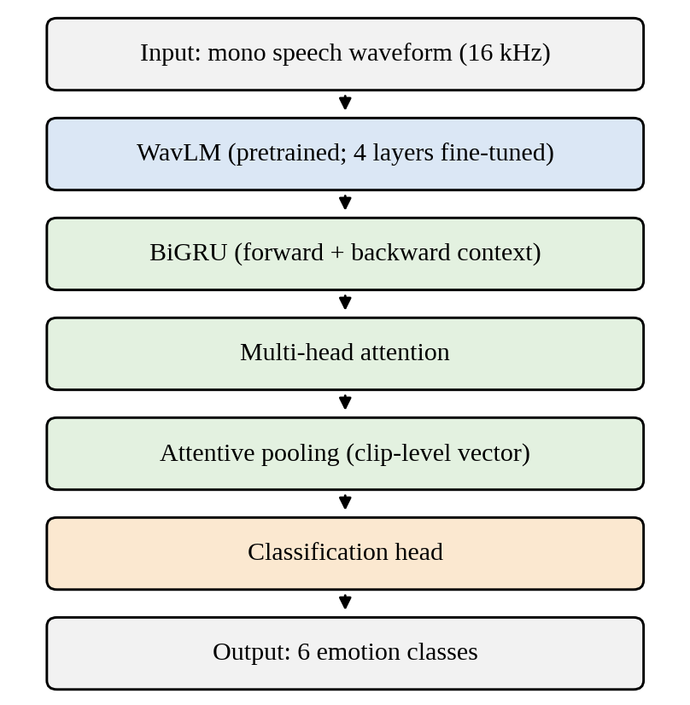
- Overview of the proposed WavLM–BiGRU–attention model.

Transfer Learning with WavLM
WavLM was pretrained on a very large amount of speech [2], so it already knows a lot about pitch, timbre, rhythm, and phonetic content. Learning all of that from 7,442 clips would be unrealistic. We reused it instead and unfroze four of its layers. Those layers can move toward emotion-related cues, while the frozen ones keep the general knowledge and keep training light enough for a single laptop GPU.

Bidirectional GRU
A Gated Recurrent Unit (GRU) [3] reads a sequence step by step and uses gates to decide what to keep and what to forget. A bidirectional GRU [4] reads the frames twice, once forward and once backward. Emotion often depends on both directions. A rising pitch at the end of an utterance, for example, changes how the beginning is understood.

Multi-Head Attention
With multi-head attention [5], every time step can look directly at every other one and decide how much it matters. Several heads work in parallel, so one can follow neighboring frames while another links distant parts of the clip. This gives the model a global view that complements the local, step-by-step reading of the BiGRU.

Attentive Pooling and Classification
Emotion is rarely spread evenly through a clip. A sharp burst of energy or a trembling pause may carry most of the signal. Attentive pooling [8] learns a weight for each time step and adds the steps up accordingly, so important frames count for more than quiet ones. The classification head then gives one score per emotion, and the highest score is the prediction.

Training Setup
We used a batch size of 2 with gradient accumulation over 4 steps, giving an effective batch size of 8. Small batches fit in the 6 GB of memory on our GPU, and accumulation keeps the updates steady. Training ran for at most 12 epochs. The learning rate started at 1.0×10⁻⁵ for WavLM and 2.0×10⁻⁴ for the new layers. The pretrained layers need the gentler rate so that fine-tuning does not erase what they already know, while the new layers start from nothing and can afford to learn faster. Mixed-precision training [9] reduced memory use and sped up computation.
After every epoch we computed macro F1-score on the validation set and kept the best checkpoint, which came from epoch 10. Only when training had finished did we load that checkpoint and run it once on the test set. The test data therefore played no part in choosing the model.
Everything ran on an NVIDIA GeForce RTX 4050 Laptop GPU with 6 GB of VRAM, using CUDA. We loaded audio with librosa [10], because the default torchaudio loader hit a TorchCodec/FFmpeg problem on our machine. The run also printed a PyTorch warning about mismatched attention-mask types. It did not interrupt training or change the evaluation, but a cleaner setup would get rid of it.

Results
Table II gives the overall test performance. The model reached 64.13% accuracy and a macro F1-score of 0.6290. Random guessing over six classes would give about 17%. The best validation macro F1-score was 0.6606, slightly higher than the test score, which is what we would expect since the checkpoint was chosen on the validation data.
- Overall Performance
Metric | Result
Test accuracy | 64.13%
Test macro F1-score | 0.6290
Best validation macro F1-score | 0.6606
Best checkpoint epoch | 10

Per-Class Performance
Table III splits the results by emotion. Angry does best, with an F1-score of 0.7532 and a recall of 0.9243, so almost every angry clip is found. Neutral is also found reliably (recall 0.9159). Disgust is the weakest class, with an F1-score of 0.5277. When the model says disgust it is usually right (precision 0.7812), but it finds fewer than half of the real disgust clips (recall 0.3984).
- Per-Class Test Performance
Emotion | Precision | Recall | F1-score | Support
Angry | 0.6356 | 0.9243 | 0.7532 | 251
Disgust | 0.7812 | 0.3984 | 0.5277 | 251
Fearful | 0.7222 | 0.5179 | 0.6032 | 251
Happy | 0.6345 | 0.4980 | 0.5580 | 251
Neutral | 0.5460 | 0.9159 | 0.6841 | 214
Sad | 0.6625 | 0.6335 | 0.6477 | 251

Confusion Matrix
Table IV shows where the mistakes go. Rows are true classes and columns are predictions, abbreviated as Ang (angry), Dis (disgust), Fea (fearful), Hap (happy), Neu (neutral), and Sad (sad). The diagonal adds up to 942 correct clips out of 1,469, which matches the reported accuracy.
- Confusion Matrix on the Test Set
Actual / Pred. | Ang | Dis | Fea | Hap | Neu | Sad
Angry | 232 | 1 | 0 | 9 | 7 | 2
Disgust | 41 | 100 | 20 | 23 | 33 | 34
Fearful | 22 | 6 | 130 | 32 | 27 | 34
Happy | 54 | 5 | 14 | 125 | 49 | 4
Neutral | 7 | 1 | 1 | 2 | 196 | 7
Sad | 9 | 15 | 15 | 6 | 47 | 159

Discussion
The model is well above chance on every class and works on speakers it has never heard, so it has clearly picked up real emotion-related patterns. The errors are just as informative. Many of them land on two classes. The model predicted angry 365 times and neutral 359 times, although these classes have only 251 and 214 true clips. When the model is unsure, it tends to fall back on one of these two. That is why both have high recall but only moderate precision.
Disgust shows the problem most clearly. Only 100 of its 251 clips were classified correctly. The rest went to angry (41), sad (34), neutral (33), happy (23), and fearful (20). Disgust does not seem to have one distinctive sound, and each way an actor might play it overlaps with another emotion. Happy clips were often labeled angry (54) or neutral (49), which is understandable if excited happiness and anger share high energy while calm happiness sounds neutral. Sad clips drifted toward neutral (47), probably because quiet, low-energy speech is close to neutral. These are our readings of the confusion patterns, and we did not test them directly.
Macro F1-score gives every class equal weight, so it is a useful partner to accuracy, especially because neutral has fewer clips. The test set is separate from the validation set used to pick the checkpoint, so the reported numbers are an honest estimate for new speakers.
There are limits. CREMA-D contains acted emotions, which are usually clearer and more exaggerated than natural speech, so real-world results could be lower. Our numbers come from a single training run, and we have not measured how much they vary with the random seed. The model also uses audio only, while CREMA-D includes video. Facial expression would probably help with classes like disgust and fear, which are hard to separate by voice.
Several improvements are worth trying. Unfreezing more WavLM layers, adding data augmentation, or weighting the loss toward hard classes such as disgust might raise recall where it is weakest. Averaging several runs would give a more reliable estimate, and testing on a second emotion corpus would show how well the model transfers beyond CREMA-D.

Conclusion
We built and tested a six-class, audio-only emotion classifier on CREMA-D. It pairs a partially fine-tuned WavLM backbone with a BiGRU, multi-head attention, attentive pooling, and a classification head. On an actor-independent test split it reached 64.13% accuracy and a macro F1-score of 0.6290. Angry and neutral speech were recognized best, and disgust worst. The confusion patterns suggest that many errors come from real acoustic overlap between emotions and not from random noise. We saved the trained model, the results file, and the validated metadata so the experiment can be repeated. Stronger fine-tuning, augmentation, repeated runs, and video input are the obvious next steps.

Acknowledgment
We thank David Cooper Cheyney and the CREMA-D contributors for making the dataset available [11].

References
- H. Cao, D. G. Cooper, M. K. Keutmann, R. C. Gur, A. Nenkova, and R. Verma, “CREMA-D: Crowd-sourced emotional multimodal actors dataset,” IEEE Trans. Affective Computing, vol. 5, no. 4, pp. 377–390, 2014.
- S. Chen et al., “WavLM: Large-scale self-supervised pre-training for full stack speech processing,” IEEE J. Sel. Topics Signal Process., vol. 16, no. 6, pp. 1505–1518, 2022.
- K. Cho et al., “Learning phrase representations using RNN encoder–decoder for statistical machine translation,” in Proc. EMNLP, 2014, pp. 1724–1734.
- M. Schuster and K. K. Paliwal, “Bidirectional recurrent neural networks,” IEEE Trans. Signal Process., vol. 45, no. 11, pp. 2673–2681, 1997.
- A. Vaswani et al., “Attention is all you need,” in Advances in Neural Information Processing Systems, vol. 30, 2017.
- M. B. Akçay and K. Oğuz, “Speech emotion recognition: Emotional models, databases, features, preprocessing methods, supporting modalities, and classifiers,” Speech Communication, vol. 116, pp. 56–76, 2020.
- A. Baevski, H. Zhou, A. Mohamed, and M. Auli, “wav2vec 2.0: A framework for self-supervised learning of speech representations,” in Advances in Neural Information Processing Systems, vol. 33, 2020.
- K. Okabe, T. Koshinaka, and K. Shinoda, “Attentive statistics pooling for deep speaker embedding,” in Proc. Interspeech, 2018, pp. 2252–2256.
- P. Micikevicius et al., “Mixed precision training,” in Proc. Int. Conf. Learning Representations (ICLR), 2018.
- B. McFee et al., “librosa: Audio and music signal analysis in Python,” in Proc. 14th Python in Science Conf., 2015, pp. 18–25.
- CREMA-D dataset repository. [Online]. Available: https://github.com/CheyneyComputerScience/CREMA-D

